

**The Arab American University**

**Faculty of Engineering and Information Technology**



**Easy Charge**

**By:**

**Shama Ahmed Abuhasan - Multimedia Technology**

**Supervisor:**

**Dr. Nizar Shehab**

**Date:**

**21-2-2021**

Table of Contents

**Declaration……………………………………………………………….3**

**List of tables……………………………………………………………..4**

**List of figures……………………………………………………………..4**

**Chapter1:Requirement Analysis**

***1.1Domain analysis***

* + 1. **Introduction ……………………………………………………………..5**
    2. **Glossary……………………………………………………………..7**
    3. **Abstract ……………………………………………………………..8**
    4. **General Knowledge………………………………………………………9**
    5. **Customer and Users……………………………………………………10**
    6. **The Environment………………………………………………………10**
  1. **Competing Software ……………………………………………………11**
  2. ***Defining the problem*……………………………………………………12**
  3. ***Types of requirements***
     1. **Functional requirements and Tasks and Procedures………………13**
     2. **Non Functional Requirement…………………………………….15**
  4. ***Gathering Information***
     1. **Observation…………………………………………………………`17**
     2. **Interviewing……………………………………………………………17**
     3. **Brainstorming……………………………………………………………18**
     4. **Prototyping…………………………………………………………….**

**Chapter two: Modeling and UML Diagrams**

***2.1Use Case Diagram*………………………………………………………..21**

* 1. ***Database Design.***
     1. **Entity Relationship Diagram (ER) ………………………………23**
     2. **Mapping the ER diagram to the Relational Database ……………24**
     3. **Tables Description……………………………………………………25**
     4. **Sequence Diagram……………………………………………………27**

Declaration

This is to declare that the graduation project entitled (Easy Charge) under the supervision of (Dr. Nizar shehab) is our own work and does not contain any unacknowledged work or material previously published or written by another person, except where due reference is made in the text of the report.

List of Tables

**Survey analysis table………………………………………..19**

List of Figures

**1.use case for the user of mobile version……………………………..21**

**2.use case for the user of company website. …………………………….22**

**3.ER for the database. ……………………………..23**

**4.mapping for database ……………………………..24**

**5. Table description for database ……………………………..25**

**6.sequence diagram for transform function……………………………..27**

**7. sequence diagram for charge function ……………………………..28**

**8. sequence diagram for request code function……………………………..29**

**9. sequence diagram for Retrieve last code……………………………..30**

**10. sequence diagram for change password……………………………..31**

**11. sequence diagram for login……………………………..32**

**12. sequence diagram for company website……………………………..33**

**13. sequence diagram for new customer in company website………………34**

**14. sequence diagram for new area in company website……………………34**



* 1. Domain analysis

* + 1. Introduction:

Our current generation is the generation of information technology, which is occupy all aspects of life, we find that all categories of society go forward to use everything which facilitate each daily process they do, so that the IT speed up daily tasks and ease the burden on citizens.

As an important point ,some people believe that the technology and smart devices are only means way for social communication ,some research and ordinary process ,In contrast the technology is a wide area of modern humanity ,sophisticated ,purposeful applications and a gateway to solve most of the problems which the society suffers from .Where the time has become a time of rest and performance of everything through smart devices, where human by nature has become capable of developing and develop herself, keep abreast of developments and receive new and convenient systems that reduce time, effort and money.

One of the important aspect at real time is “the electricity charging process”, which passed through several stages and takes an important position in the world of technology, so that there are permanent updates in this area to facilitate the process of charging electricity meter to citizens and we believe that our application will be the most important one of these updates.

Electricity is an essential element of our daily life. When you look around, you will find that it is impossible to find a place without an electric machine or an electric appliance. If we wake up one day and we find that the power is cut off, we feel upset, troubles grow and we may get angry if we cannot go to charge the electricity card because electricity charging center is far and it may be closes, because it is not available for 24 hours daily. So can you wait many hours with no television, radio, laptops, Washing Machine, Refrigerator, telephone and many electric machines? can you take permission to leave your work to recharge your card?

we can say that the main problems which our idea of this project grew out from them include several aspect especially when the electricity turn off. First of all, difficulty of reaching the ECC which may be far from the residential areas .Secondly, some of the conditions that make this process difficult may arise, such as the political situation. Thirdly, it may be difficult for elderly people to go for a long distance. In addition, the major problem will be for people with special needs. Also, people steal electricity from each other by cutting wires from the meter which is accessible to everyone. As an important point, ruin or loss of electricity card costs the citizen a lot of effort and force her to take many steps to create a new card. Finally, a real problem may happen if the ECC is closed. According to all these points we believe that our new technique will be ground breaking idea and solve all the critical points that we talked about.

The thesis of this application grew as an humanity thought for the elderly, our application considered as a way to make it easier for them to accomplish the process of charging and reduce the effort they consumed during this process especially the time they take to reach the place of ECC , our application has also evolved to target many other categories such as: people living in residential areas which are far from services, travelers, people who are at work and housewives who work in their own businesses.

we can include the idea of our application in some points: it will allow the user to charge the electricity meter using our mobile application features, using our application, user can be able to enter her meter number and the quantity of electricity that she wants, then the electricity company will automatically send back a message include code to her, then she will enter the code. In addition, she can transfer amount of electricity from her account to another account.

In this report we will discuss tow chapters Requirement Analysis and Modeling and UML Diagrams, the first chapter which include five parts. First of all, domain analysis, it is include an introduction about the proposed system, list of glossaries , abstract, general knowledge, customers and users and the environment will use in our system. Secondly, competing software. Third , definition for the problem. In addition, types of requirement which divide into functional requirement and non functional requirement. Finally, gathering information which divide into observation, interviewing, brainstorming, prototyping. The second chapter is Modeling and UML Diagrams which include two parts. First of all, use case diagram it means the scenarios the system go through. Secondly, database design, it is include Entity Relationship Diagram (ER), Mapping the ER diagram to the Relational Database (Database Diagram), tables description and sequence diagrams.

1.1.2 Glossary

Information technology………IT

Charging electricity meter………CEM

Electricity charging center……….ECC

Electricity company……………...EC

Electricity charging process……..ECP

1.1.3 Abstract

The main problems which our idea of this project grew out from them include several aspect especially when the electricity turn off. First of all, difficulty of reaching the ECC which may be far from the residential areas .Secondly, some of the conditions that make this process difficult may arise, such as the political situation. Thirdly, it may be difficult for elderly people to go for a long distance. In addition, the major problem will be for people with special needs. Also, people steal electricity from each other by cutting wires from the meter which is accessible to everyone. As an important point, ruin or loss of electricity card costs the citizen a lot of effort and force her to take many steps to create a new card. Finally, a real problem may happen if the electricity shipping center is closed. According to all these points we believe that our new technique will be ground breaking idea and solve all the critical points that we talked about.

We can summarize the main concepts of our application in some points: it allows the user to mainly request a code to charge her meter by enter the number of her meter which specify the overall process, because each meter has specific codes, the user must enter his cash card serial number ,our system prevents the user form complete the charge process if she does not has money on her cash card which is a card given with the meter and the user fill it with money, if she has a sufficient money to charge she will receive the code then our system allow the user to use this code and charge the meter wireless, the company website should return an encrypted code to the right user after all taxes have discounted and allow the user of this company to request enquiries about the meters and the charge and transform requests. In addition, our mobile application allow user to transform electricity from her account to anther this process will complete by pull the code which does not charged , the receiving meter id and the amount , if the amount is available our application will generate a code for the received meter and a code for the sender with the remaining money . As important case, if the mobile turn off or the internet disconnect the user can retrieve the last code if she could not charge it before this problem. Finally, the user can make queries from the system either the summation of amount of charging processes during a specified interval and the summation of amount of transfering processes during a specified interval.

The thesis of this application grew as an humanity thought for the elderly, our application considered as a way to make it easier for them to accomplish the process of charging .

1.1.4 General Knowledge:

To maintain the life of the human community, and in order to facilitate the life, many important inventions were discovered. There is no doubt that the most important of these inventions is electricity, which we depend on in the current modern time. We better understand the importance of electricity in our life during a few minutes of power outages we encounter. The people’s social life almost stops in power outages. They do not know what to do. They cannot carry out activities they made a habit of. For instance, computer and television, that we are addicted to, are the best examples of these. This is an indicator of how much electricity is important in our lives.

Several years ago we noticed the suffering of the employees of the EC, they were facing several problems when moving between houses to read the electricity meters and complete the process, as a personal experience sometimes there was no one at our home or we could not receive them, all of this went on for a long time until a new technique was introduced by a card inserted into the electricity meter.

we can summarize the main problem of the last mentioned technique “electricity card” in some points , for example: difficulty accessing the ECC which may be far from the residential areas, some of the conditions that make this process difficult may arise, it may be difficult for elderly people, people with special needs and a major problem may happen if the electricity turn off, according to all these points we think about a new technique we believe that it will be ground breaking idea and solve all critical points that we talked about.

But before we talk about the details of our application, we will mention some details about the last technique which use the electricity card which include a code provided by the electricity company, this code includes numbers that will be enter into the meter and this technique is safety, easy, protect from theft electricity and support GSMODEM used by SIM card , so our application will be complementary to this new technique.

After reviewing the only somehow considered as similar applications that only focus on the payment process on several aspect such as water, electricity and travels bills, this application activated in Jordan and it does not keep pace the new techniques for electricity charging because there is no bills technique for electricity charging at our community ,they use the direct payment for the electricity charging center, but our application exceed this application and more advance than it and another application in ASAL company which use Bluetooth to has direct interaction with the meter to be able to charge it or retrieve the current value, but it is limited to three floors and do not allow the user to transfer.

we can include the idea of this application in some points :the application will allow the user to charge the electricity meter using our mobile application features ,this application indirectly give user a cash card to complete the payment process , user can be able to enter her meter number , the quantity of electricity she wants and her cash card id , the system will check if she has money on the card, then an automatically process will be done by send back a message include code to the user, then the user will enter the code either on the meter or into the software part of the application ,which allow user to charge the meter. In addition, you can transfer amount of electricity to someone account throw this application.

1.1.5 Customer and Users:

The most important aspects are to know which categories dose the application targeted.

In general, our application concern for all categories in the society, because its main target to serve all people who are suffering from the difficulty of charging the electric meter because of several problems such as: the power outages at late times of night and if the electricity charging stations closed and it is not available for 24 hours daily and many other problems.

Our application targeted each person in the society who want to do and complete the process of charging his electric meter faster and without any suffering, and for 24 hours daily.

1.1.6 The Environment:

* Mobile application: we will use the most famous environment to build the application which make a cross platform for Android and IOS “Java Script” ‘ionic’, Visual studio code.
* For database: sql server management studio.
* company website: using visual studio.

1.2 Competing software

الثلاثاء, 19 ديسمبر 2017 19:31

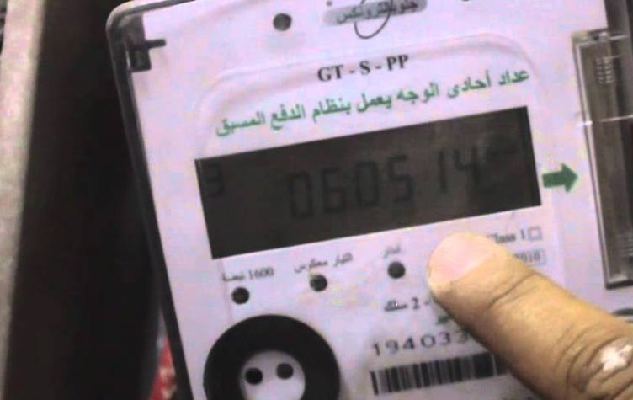

The new counter features mobile phone access via Bluetooth technology, allowing the subscriber to charge the meter at any time of the day and from inside his home without having to go to the electricity company's charging centers.

 The subscriber will then download the application to his mobile phone and activate it. When the service is selected and the meter appears on the mobile screen, the subscriber data will be called from the server. The subscriber will be able to carry out the charging process in one step without using a recharge card. .

The advantage of the new counter is that the charging process can take place even if the meter is far enough to reach three floors. The citizen can charge the meter in the basement or the entrance to the property while sitting at home without moving to it. The subscriber can call the remaining balance on the meter on the screen Phone to confirm that the shipping balance has successfully arrived.

1.2 define the problem

In the recent days there is a major problem with ECP, many people are suffering from charging their electric cards because of many issues such as: difficulty accessing the ECC, which may be far from the residential areas, some of the conditions that make this process difficult may arise, it may be difficult for elderly people, people with special needs and a major problem may happen if the electricity turn off, in consideration of all these points we think about a new technique, we believe that it will be ground breaking idea and solve all critical points that we talked about.

The technique will allow the user to charge the electricity meter using our mobile application. Through our mobile application the user can request from the EC the amount of electricity that he wants to charge his electric meter, and then he receives a code from the ECC , when he enters this code in the electric meter, the required amount is automatically supplied and added to his electric meter.

1.4 types of functional requirement

**1.4.1 functional requirement:**

**For the mobile application:**

1. login: this function need the user to has an account to enter the system ,

then the user will go to the main page, the system introduces five choices for the user in the main page:

A –request: this function will allow the user to enter her meter number which written in the meter , enter the amount of money she want to charge with and enter the serial number of her card to complete the pay process then she will press a submission button , all these information’s will save in the data base of the web site and the mobile application for the enquiry information in both website and mobile application.

(Filling the electricity card)

After entering the previous process the interface which contain the option charge your meter: this function will allow the user to accomplish the process of charging the meter via show page contain a field to enter the code which retrieved from the website system then the meter which programmed via a wireless will be charged.

(charging the electric meter)

B-transformation: this function allows the user to trans amount of electricity from a returned code which has status ‘0’ to another meter using an interface that asks the user to enter her OTP code which she want to transfer from , the number of the destination meter and the amount of money she wants to trans, then a submission button will check these information and checks if the user has enough money in this code, then the system will send a message to the user to confirm or reject the process, if she confirms it, the application automatically reduces the amount of money from the user OTP ,send a code to the user and create a new OTP code for the sender with the remaining amount , then either the user will charge the OTP returned for her and for the reception meter or the charge page is appeared to enable the user to enter the received code to charge the destination meter.

C-Enquiry: this will provide the ability to several queries but the user should has an account to show her meter information so this function will trans the user to page ask the user to login or create an account then after login the user will be able to :

1- check the electricity transformation processes.

2- check the electricity charging processes.

3-check the amount of charging between two dates.

D-last code: this function will allow the user to retrieve the last code form the mobile data base if any error happened.

E-charge the meter wireless: this function will allow the user to charge the meter after receiving the code .

F-Change Password: this enable the user to change her account password which the company employee gave her.

**For the company website:**

1-login: this function need the user to has an account to enter the system .

2- after login the user has two function to do:

* Enquiries about the citizens and their charging processes: allow the employee to check the details of the charge processes that completed, the current value in any meter and other queries.
* Check the charge notifications: this function allow the employee to view the notifications that reaches from the citizens(the orders to charge electricity).
* Check the transformation notifications: this function allow the employee to view the notifications that reaches from the citizens(the orders to transform electricity).
* Create new customer: this function allow the employee to create a new card information , new meter and a new customer information which gave her the username and password to enter the mobile application.
* Create new Area: this function allow the employee to enter a new area information which may be state(s) or city (c) or town(t).
* Require code for a specific meter: this function allow the employee to require an OTP code via an interface she enter the meter number and the amount she want to charge and the card serial number for this meter then press the submission button then the system will return OTP and she can charge it wireless.
* Charge meters: this function allow the employee to check charging process and charge any meter which has a code with status ‘0’.

**1.4.2 non functional requirement:**

* **Reliability**: the proposed application is expected to consistently perform its intended functions with required precision and without degradation or failure. It is going to handle the most likely errors that may cause the system to degrade and therefore, making failures less likely to happen. We can insure that by using a high performance language which support high security, make sure that we include all failure cases may face the user, dealing with good server which tolerate very huge amount of users and make sure that he server will not be down.
* **Efficiency**: the amount of computing resources and code required by the proposed application to perform its functions are going to be optimized, so that achieving a high performance system. SO we should do complexity analysis for the code and make sure it will be encrypted and unique with high performance.
* **Integrity**: the access to software and data by unauthorized persons are controlled. For instance, only the admin has the authorization to manipulate the application's content. Moreover, the users inquiries are answered by the system such the inquiries option in our system which will be answered by the system using queries and database tables and the user must login to see these queries results.
* **Usability**: Concerned with the ease of use of the proposed system, our system will be used by different layers of people have different mental levels. The proposed application will be used by specified users to achieve their specified goals with effectiveness, efficiency, and satisfaction in the context of use. It is characterized by an attractive, consistent and learnable user interface, so we will take in account to make learnable area for the users.
* **Correctness**: the proposed application satisfies its specifications and fulfills the users' mission objectives. It displays only the correct results to the users' requests. Such as sending the right calculations for the inquiries of the users to the right user, and displaying accurate calculations to each user.
* **Maintainability**: the effort required to locate and fix errors in the system will be reduced by using proper comments, coding conventions, breaking up big methods, updating the used strings from one location in the platform, using the main direct control panel interface to manipulate the application's content.
* **Flexibility**: the users have many choices to perform the same functionality from different locations in the interface, such as "charge the meter" functionality. Moreover, using flexible interface layouts to adapt any future content updates, and resizing the texts and images according to the mobile screens' resolutions.
* **Scalability**: the proposed application is able to grow and expand, as it is initially a piloting version in Municipalities dealing with North Electricity Company, and then it is intended to be applied in other electricity company in Palestine and maybe outside.
* **Security**: the degree of resistance to, or protection from, harm is going to be high, by using encryption methods, special codes and passwords for each user. So, we will use encryption/decryption methods in your application.
* **Privacy**: The system will ensure that only authorized users can gain access to her account and prohibit any unauthorized access by using different techniques in software development. Such the enquiries option the user can not access to her information until she access to her

account and the employee in the company website cannot access to it until she access to her account.

1.5 gathering information

1.5.1 observations:

At the beginning we will talk about some notes we obtained them after we go through gathering information phase for our system, we notice that our application will be very successful and will be used because of suffering, which many citizens face when they go to ECC, which very far for most citizens and not available for twenty four hours.

According to the interviews we do with the electricity company we found that our idea is wanted and they are ready to support it, they encouraged us.

As a result from the survey for the targeted audience we found that they will benefit from our application especially those who find a problem with electricity charging when it interrupt during their work or travel or for women’s when they be alone in their houses, so they found our system as radical solution for their problems.

The electricity is a very big issue which cause worry in many homes and public places, and if we think about the stages that charging electricity have passed through, we find that the electricity charge is a subject that needs development and attention and it is a problem that is not observed. The step we took in our project will achieve great success and solve a problem that cause worry.

1.5.2 interviewing:

As a major part in our system is to make interviews with our targeted audience, with the customer and with the supporters to take a feedback which is very important in determining the functional requirement for our system, for instance we make interviews with:

1-at first with the major benefited and supporter North Electricity Company, they encouraged our idea, they demonstrate that the new meter which allow to enter a code instead of enter the electricity card is complementary to our idea and facilitate our works, they say that they need our idea to be applied and they give us all permission to take advices from them and support us.

2-And as one of the samples targeted for this application Municipality of Yabad they were proud of this idea, they encouraged this destination, they mention that the electricity charging is a big worry to most of citizens, they give us a very valuable information which complete the concept of our application and they strongly recommended that the application should be secure for citizens.

In general after reviewing with many places our application take confidence from them to be the breakeven point in our society.

1.5.3 Brainstorming:

One of the important aspect at real time is “ECP”, which passed through several stages and takes an important position in the world of technology, so that there are permanent updates in this area to facilitate the process of charging CEM to citizens and we believe that our application will be the most important one of these updates.

Our new idea is chosen from many other ideas and after e checked the pros and cons for each idea we reached that our current idea is the best this is come from our current generation which is the generation of technology and people go forward to use everything facilitate daily tasks and one of the most tasks which attract us “electricity charging” , because different problems face the citizens during this process. First of all, difficulty of reaching the electricity charging center which may be far from the residential areas .Secondly, some of the conditions that make this process difficult may arise, such as the political situation. Thirdly, it may be difficult for elderly people to go for a long distance. In addition, the major problem will be for people with special needs. Also, people steal electricity from each other by cutting wires from the meter which is accessible to everyone. As an important point, ruin or loss of electricity card costs the citizen a lot of effort and force her to take many steps to create a new card. Finally, a real problem may happen if the ECC is closed. According to all these points we believe that our new technique will be ground breaking idea and solve all the critical points that we talked about.

Our idea will allow the user to charge the electricity meter using our mobile application features, using our application, user can be able to enter her meter number and the quantity of electricity that she wants, then the EC will automatically send back a message include code to her, then she will enter the code. In addition, she can transfer amount of electricity from her account to another account, but there is some complexity with paying off process, but we solve this problem and designed a website interface allow the citizen to transfer money from the citizen account to company account

**This is the analysis for our survey**

|  |  |  |
| --- | --- | --- |
| question | Feed back | How we implement it |
| Where are you from? | All of them from Palestine cities and countries | Our proposed system until this day will be for the Palestinian north electricity company and any other company which use STS , and as a future work we will work on it in order to use in other countries and other companies |
| Do you think you will benefit from the proposed application? |  | This lead us to recognize that our system will be benefit for almost all people and it is needed in our society. |
| Have you ever used a similar application for the proposed app? |  | This mean that our application is ground breaking idea and is an innovation to build this proposed system. |
| If you use a similar application before, please attach the name of the application and the medium used on the application (mobile or web application) | Most of them mention  \ دفع القواتير والاتصالاتJDECO APP  والانترنت عن طريق الموبايل \ عربي اون لاين\ تطبيق إعادة تعبئة رصيد الجوال عبر تطبيق موبايل \الدفع عبر الفيزا\ ding top-up\ شحن فواتير جوال | As we see they also mention the applications allow the user to retrieve information about the meter. |
| Do you have access to shipping places to charge your electricity bill? |  | This indicates that the main problem we talked about is really existing and people need like our application |
| Do you own a bank account? |  | This is demonstrate that almost all people has bank account and can use our application , and for those who do not have an account we will use cash card for pay.  So we will choose one method for pay. |
| If the application was created, how would you prefer to pay the electricity suppliers? |  | This question play main rule in order to decide which payment method the use.  As we see people need a trust method to pay.  We decide to use cash card like visa card but the electricity company will give it with meter. |
| Do you have any suggestions that you would like to consider in the proposed application? | They emphasize on the security. | We will use encrypted code and database and use a confirmation messages |

Analysis table

Chapter two: Modeling and UML Diagrams

2.1 Use case diagram

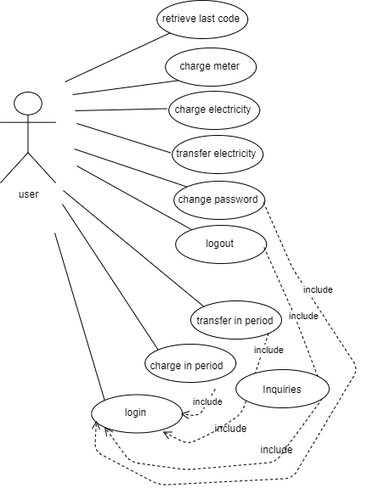

1. Use case for the user of mobile version

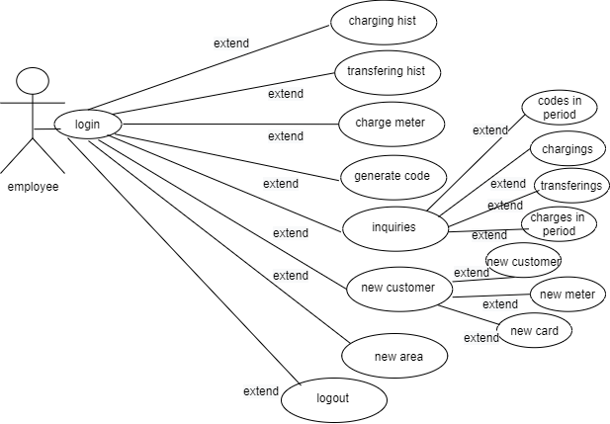

2.Use case for the user of company website

2.2 Data Base design diagram

2.2.1 Entity Relationship Diagram (ER):

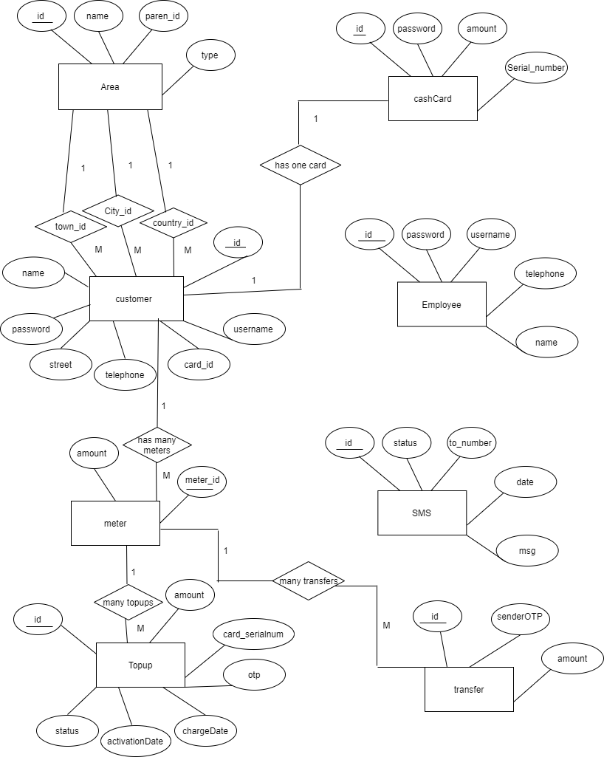

2.2.2 Mapping the ER diagram to the Relational Database (Database Diagram):

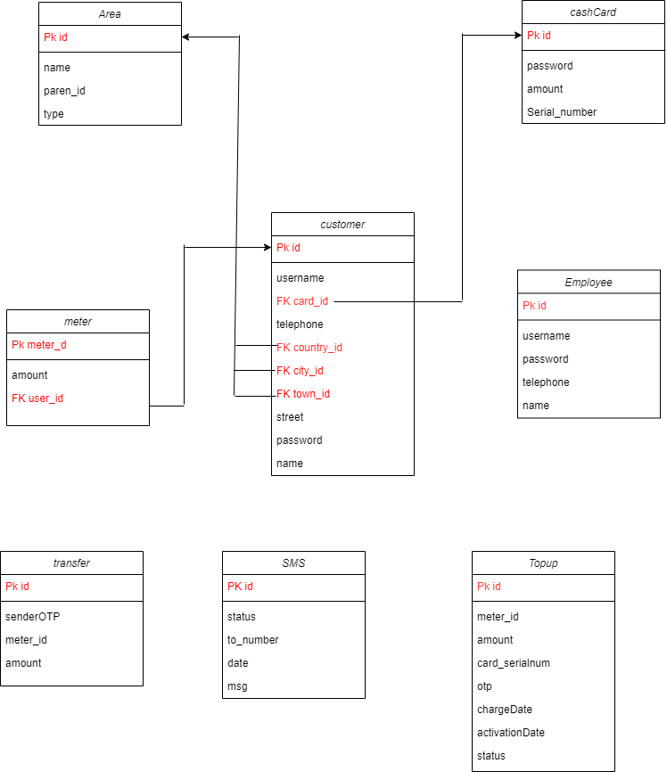

2.2.3 Tables Description

|  |  |
| --- | --- |
| id | int,unique,not null |
| name | nvarchar(32), not null |
| paren_id | int, allow null |
| type | nvarchar(16), not null |

Area

|  |  |
| --- | --- |
| id | primary key, auto increment |
| password | varchar(64), not null |
| amount | decimal(9,2), not null |
| Serial_number | varchar(16), unique, not null |

cashCard

|  |  |
| --- | --- |
| id | Primary key, auto increment |
| username | nvarchar(32),unique, not null |
| card_id | varchar(16),foreign key , not null |
| telephone | varchar(16), not null |
| country_id | integer, not null |
| city_id | integer, not null |
| town_id | integer,not null |
| street | nvarchar(64),not null |
| password | nvarchar(64),not null |
| name | nvarchar(32),not null |

customer

|  |  |
| --- | --- |
| id | Primary key, auto increment |
| username | nvarchar(32),not null,unique |
| password | nvarchar(64),not null |
| telephone | varchar(16), not null |
| name | nvarchar(32),not null |

Employee

|  |  |
| --- | --- |
| amount | decimal(9,2),not null |
| meter_id | varchar(16),not null ,primary key |
| user_id | integer,foriegnkey |

meter

|  |  |
| --- | --- |
| id | varchar(50), not null,primary key |
| status | nvarchar(32),not null |
| to_number | varchar(50), not null |
| date | date |
| msg | nvarchar(520),not null |

SMS

|  |  |
| --- | --- |
| id | Primary key, auto increment |
| meter_id | varchar(16),not null |
| amount | decimal(9,2), not null |
| card_serialnum | varchar(16),not null |
| otp | bigint ,not null ,sequence number |
| chargeDate | Date |
| activationDate | Date,allow null |
| status | char(1) |

Topup

|  |  |
| --- | --- |
| id | Primary key, auto increment |
| senderOTP | bigint ,not null, sequence number |
| meter_id | varchar(16),not null |
| amount | Decimal(9,2), not null |

transfer

2.2.4 sequence diagrams

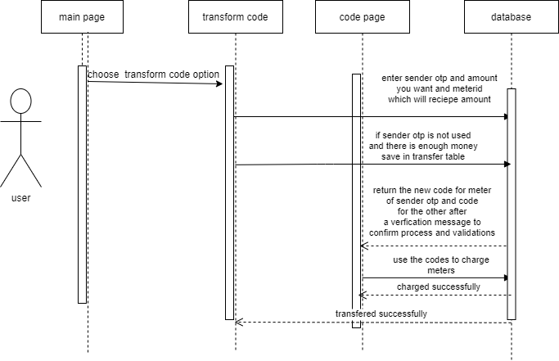

6.Sequence diagram for transform function

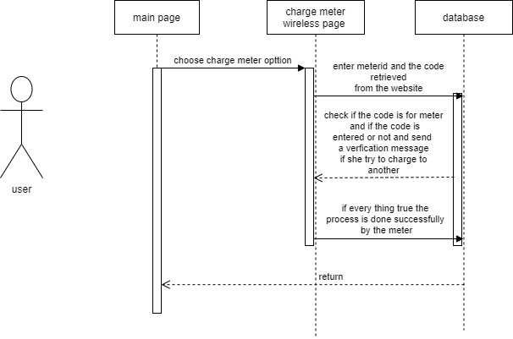

7.sequence diagram for charge meter.

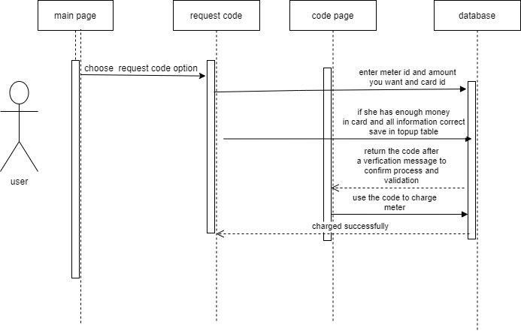

8.sequence diagram for request code function.

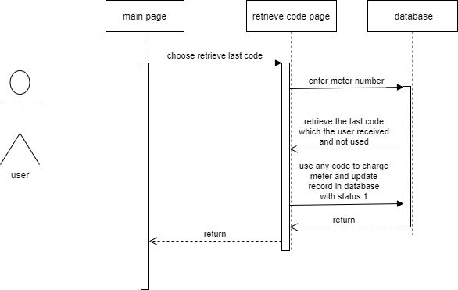

9.Sequence diagram for retrieve the last code

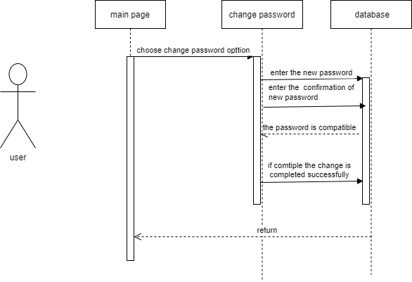

10.Sequence diagram for change the password

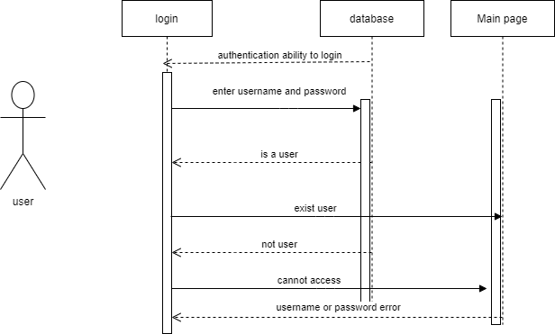

11.Sequence diagram for login

Sequence diagrams for mobile version

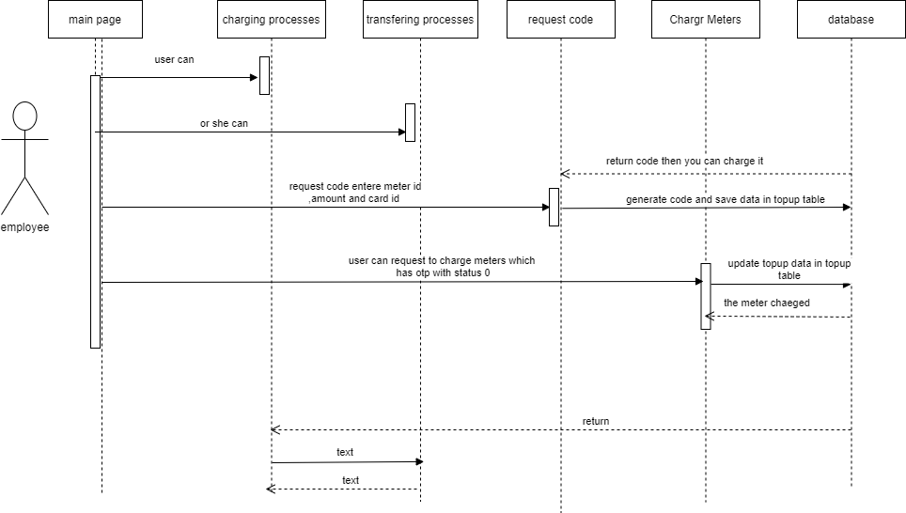

12.Sequence diagram for company website

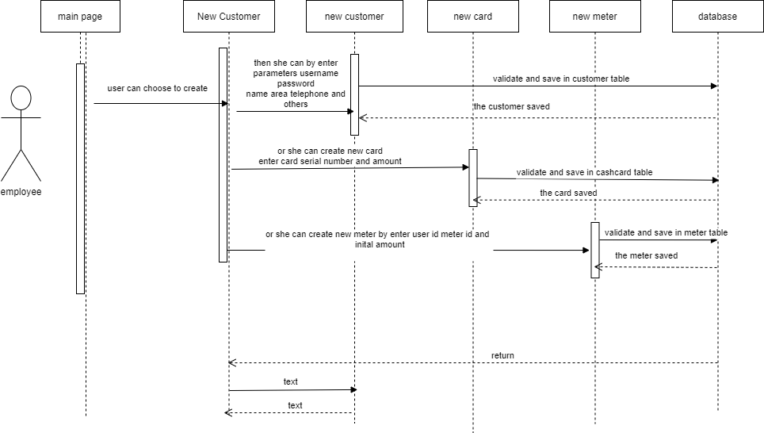

13.sequence diagram for new customer in company website

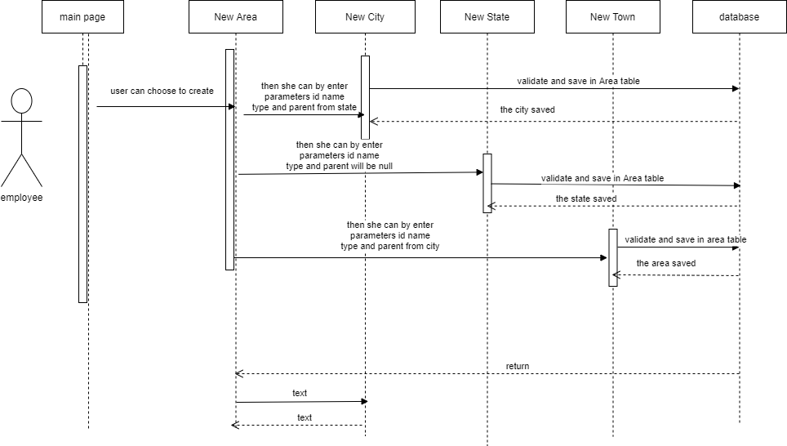

14.sequence diagram for new area in company website